***Student Research on E-Commerce***

***Introduction of E-commerce***

* E-commerce, while having roots in earlier systems like Electronic Data Interchange (EDI) and the CompuServe network, is generally considered to have begun in 1982 with the launch of Boston Computer Exchange. This early platform facilitated E trading used computers, marking the beginning of online commerce.
* 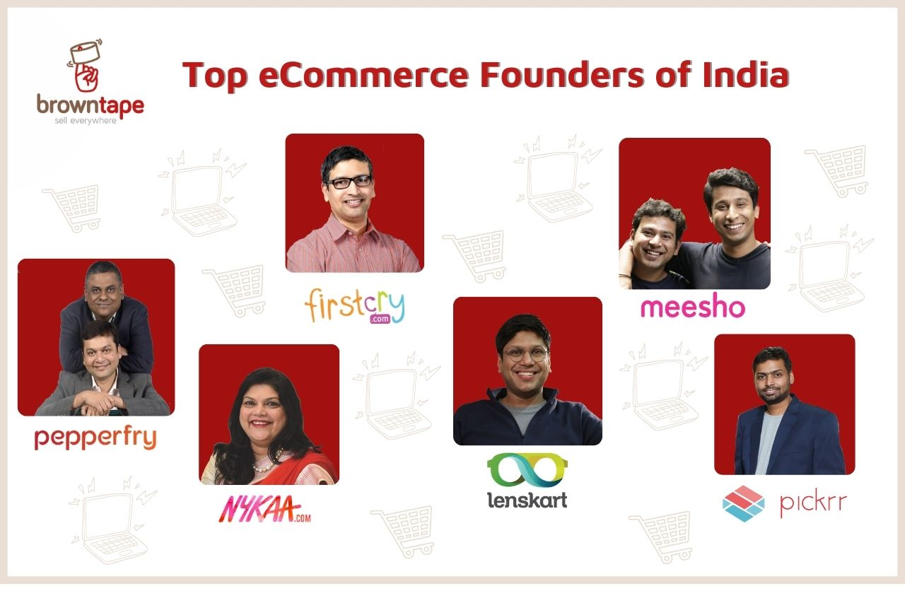E-commerce, while having roots in earlier systems like Electronic Data Interchange (EDI) and the CompuServe network, is generally considered to have begun in 1982 with the launch of Boston Computer Exchange. This early platform facilitated trading used computers, marking the beginning of online commerc

***Key Takeaways***

* E-commerce is the buying and selling of goods and services over the internet.
* It is conducted over computers, tablets, smartphones, and other smart devices.
* Almost anything can be purchased through e-commerce today, and it has lowered the barriers to entry for many types of businesses, such as retailers.
* E-commerce can be a substitute for brick-and-mortar stores, though some businesses choose to maintain both.
* E-commerce operates in several market segments, including business-to-business, business-to-consumer, consumer-to-consumer, and consumer-to-business.

***Understanding E-commerce***

As noted above, e-commerce is the process of buying and selling products and services online. But it involves more than simply a buyer and a seller, relying on a vast, ofteninvisible, infrastructure to keep it running.

E-commerce has helped companies (especially those with a narrow reach, like small, local businesses) gain access to a wider market by providing cheaper and more efficient sales and distribution channels for their products or service.

***History of E-commerce***

Most of us have shopped online for something at some point, which means we've taken part in e-commerce. So it goes without saying that e-commerce is everywhere. But very few people may know that e-commerce has a history that predates the internet.

E-commerce actually goes back to the 1960s, when companies used an electronic system called the Electronic Data Interchange to facilitate the transfer of documents. It wasn't until 1994 that the very first transaction took place. This involved the sale of a CD between friends through an online retail website called NetMarket.1

The industry has evolved rapidly since then, with companies like [Alibaba](https://www.investopedia.com/articles/investing/121714/how-does-alibaba-make-money-simple-guide.asp) and [Amazon](https://www.investopedia.com/how-amazon-makes-money-4587523) becoming household names around the world. The introduction of free shipping, which, at least on the surface, reduces costs for consumers, has also helped increase the popularity of the e-commerce industry.

***Advantages and Disadvantages of E-commerce***

Advantages

E-commerce offers buyers and sellers a number of advantages:

* **Convenience**: E-commerce can happen 24 hours a day, seven days a week. Consumers can buy at their convenience, and business owners can make sales while they sleep.
* **Increased selection**: Many stores offer a wider array of products online than they could ever carry in their brick-and-mortar counterparts. And many stores that solely exist online offer consumers exclusive inventory that is unavailable elsewhere.
* **Potentially lower start-up costs**:E-commerce companies may require a warehouse or manufacturing site, but they usually don't need a physical storefront. The cost to operate digitally is often less expensive than needing to pay rent, insurance, building main**Limited customer service**: If you shop online for a computer, you cannot simply ask an employee to demonstrate a particular model's features in person. And although some websites let you chat online with a staff member, that is not a typical practice. A disadvantage for shoppers, this can also be a money-saver for retailers.
* **Lack of instant gratification**: When you buy an item online, you must wait for it to be shipped to your home or office. However, [e-tailers](https://www.investopedia.com/terms/e/electronic-retailing-e-tailing.asp) like Amazon now make the waiting game a little bit less painful by offering same-day delivery as a premium option for select products.
* **Inability to touch products**:Online images do not necessarily convey the whole story about an item, and e-commerce purchases can be disappointing when the items don't live up to the buyer's expectations. Case in point: an item of clothing may be made from shoddier fabric than its online image indicates.
* **Dependence on technology**: If a website crashes or must be temporarily taken down for any reason, the business is effectively closed until things return to normal.
* **Greater competition**:Although the low cost of starting an e-commerce business can be an advantage, it also means means competitors can just as easily enter the market.
* **Pros**
* Convenient for consumers, often with greater selection
* Potentially low start-up costs for operators
* Broadens reach of businesses to anywhere they can ship their products.
* Opportunity to collect valuable consumer data
* **Cons**
* Limited customer service or assistance
* Products can't be touched
* Buyers must wait to receive purchases
* Technological glitches can shut down the business
* Low cost barriers to entry can also mean more competitors
* **Types of E-commerce**
* tenance, and property taxes.
* **International sales**:As long as an e-commerce store can find a way to ship its products to its customers, it can sell to anyone in the world and isn't limited by physical geography.
* **Opportunity to collect valuable data**:Willingly or unknowingly, consumers share a lot of information on their interests and shopping habits when they buy or even just browse online.  in a number of ways, using it themselves and selling it to others.

***Disadvantages***

There are also some drawbacks that come with e-commerce. Those can include:

* **Limited customer service**: If you shop online for a computer, you cannot simply ask an employee to demonstrate a particular model's features in person. And although some websites let you chat online with a staff member, that is not a typical practice. A disadvantage for shoppers, this can also be a money-saver for retailers.
* **Lack of instant gratification**: When you buy an item online, you must wait for it to be shipped to your home or office. However, [e-tailers](https://www.investopedia.com/terms/e/electronic-retailing-e-tailing.asp) like Amazon now make the waiting game a little bit less painful by offering same-day delivery as a premium option for select products.
* **Inability to touch products**:Online images do not necessarily convey the whole story about an item, and e-commerce purchases can be disappointing when the items don't live up to the buyer's expectations. Case in point: an item of clothing may be made from shoddier fabric than its online image indicates.
* **Dependence on technology**: If a website crashes or must be temporarily taken down for any reason, the business is effectively closed until things return to normal.
* **Greater competition**:Although the low cost of starting an e-commerce business can be an advantage, it also means means competitors can just as easily enter the market.

***Pros***

* Convenient for consumers, often with greater selection
* Potentially low start-up costs for operators
* Broadens reach of businesses to anywhere they can ship their products.
* Opportunity to collect valuable consumer data

***Cons***

* Limited customer service or assistance
* Products can't be touched
* Buyers must wait to receive purchases
* Technological glitches can shut down the business
* Low cost barriers to entry can also mean more competitors

***Types of E-commerce***

There are many **types of e-commerce models**, based on [market segmentation](https://en.wikipedia.org/wiki/Market_segmentation), that can be used to conducted business online. The 6 types of business models that can be used in

* [e-commerce](https://en.wikipedia.org/wiki/E-commerce) include:[[1]](https://en.wikipedia.org/wiki/Types_of_e-commerce#cite_note-javedarslan-1) [Business-to-Consumer](https://en.wikipedia.org/wiki/Business-to-consumer) (B2C), [Consumer-to-Business](https://en.wikipedia.org/wiki/Consumer-to-business) (C2B), [Business-to-Business](https://en.wikipedia.org/wiki/B2B_e-commerce) (B2B), [Consumer-to-Consumer](https://en.wikipedia.org/wiki/Customer_to_customer) (C2C), [Business-to-Administration](https://en.wikipedia.org/wiki/Business-to-government) (B2A), and Consumer-to-Administration .

***Faces Challenges in E-Commerce***

E-commerce comes with its fair share of obstacles, even as it continues to evolve at lightning speed. Here are some key challenges businesses face:

* **Intense Competition:** With countless online stores fighting for customer attention, standing out can be difficult.
* **Customer Trust:** Security concerns, fraud risks, and unreliable sellers can make shoppers hesitant.
* **Logistics & Delivery:** Managing inventory, ensuring quick deliveries, and handling returns efficiently is a major hurdle.
* **Personalization & Engagement:** Keeping users engaged, offering tailored experiences, and reducing cart abandonment require constant innovation.
* **Payments & Fraud Prevention:** Secure and seamless payment options are crucial, but cyber threats are an ongoing battle.

***Thought process in E-Commerce***

E-commerce operates through a well-defined thought process that involves various stages, from market analysis to customer satisfaction. Here’s a breakdown of its core principles:

* **Understanding Market Needs** – Identifying gaps in the market and determining what customers want.
* **Business Model Selection** – Choosing between B2B, B2C, C2C, or D2C approaches.
* **Platform Development** – Building a user-friendly website or app for seamless transactions.
* **Product Sourcing & Inventory Management** – Ensuring an efficient supply chain and stock availability.
* **Marketing & Customer Acquisition** – Using SEO, social media, and ads to attract buyers.
* **Secure Payment Processing** – Implementing payment gateways for smooth transactions.
* **Customer Experience & Retention** – Prioritizing fast delivery, quality service, and personalized interactions.
* **Data Analytics & Growth Strategy** – Studying customer behavior and refining operations.

***Plan Tools of E-Commerce***

E-commerce businesses rely on a variety of tools to plan, manage, and optimize their operations. Here are some key categories of tools that help with planning:

1. **Website & Store Builders** – Platforms like Shopify, WooCommerce, and Magento help businesses set up and customize their online stores.
2. **Payment Gateways** – Secure transaction tools like PayPal, Stripe, and Razorpay ensure smooth payment processing.
3. **Inventory Management** – Solutions like Zoho Inventory and TradeGecko help businesses track and optimize stock levels.
4. **Marketing & SEO** – Tools like Google Ads, SEMrush, and Mailchimp enhance visibility and customer engagement.
5. **Customer Relationship Management (CRM)** – HubSpot, Salesforce, and Zendesk assist with customer interactions and support.
6. **Analytics & Reporting** – Google Analytics, Hotjar, and Power BI offer insights into customer behavior and sales performance.
7. **Logistics & Shipping** – FedEx, ShipRocket, and DHL tools ensure efficient order fulfillment and delivery.
8. **Security & Fraud Prevention** – Tools like Cloudflare and Norton protect against cyber threats.
9. **Chatbots & AI Assistants** – Solutions like Drift and Intercom improve customer support through automated responses.

***Makes Solution of Creativity***

An effective e-commerce solution is built on several key components that work together to create a seamless experience for businesses and customers alike. Here’s what makes a strong e-commerce solution:

1. **User-Friendly Website** – An intuitive and responsive design ensures customers can easily browse and make purchases.
2. **Secure Payment Gateway** – Reliable payment processing with multiple options (credit/debit cards, digital wallets, UPI, etc.).
3. **Robust Inventory Management** – Efficient tracking and updating of stock levels in real time.
4. **SEO & Digital Marketing** – Optimized product listings and marketing strategies to drive traffic and boost sales.
5. **Customer Support & Engagement** – Live chat, email, and AI-powered assistance to enhance customer experience.
6. **Mobile Optimization** – A well-optimized mobile interface or app to cater to users shopping on smartphones.
7. **Logistics & Order Fulfillment** – Efficient delivery systems with proper tracking and return management.

***Inspired or Surprised You E-commerce*** E-commerce is an industry that never ceases to surprise and evolve. One of the most inspiring aspects is how it has democratized business—anyone with an idea and an internet connection can start selling globally. It’s leveled the playing field, allowing small entrepreneurs to compete with established giants.

What’s surprising is the sheer speed of innovation. For example, live shopping—where influencers and brands host real-time sales events online—has taken off in ways few predicted. And the rise of AI-powered personalized shopping, where algorithms tailor recommendations with uncanny accuracy, makes the experience feel almost human.

Another fascinating development is how sustainability has become a priority. Companies are investing in greener supply chains, ethical sourcing, and eco-friendly packaging as consumers demand more responsibility from brands.

***Innovation of E-Commerce***

E-commerce has been evolving rapidly, and innovation in this space has transformed how businesses and consumers interact. Here are some key trends I’ve observed:

* **AI & Automation:** Machine learning and AI-driven personalization help businesses provide tailored recommendations, chatbots improve customer service, and automation streamlines inventory and order management.
* **Omnichannel Experiences:** Customers expect seamless transitions between online and offline shopping, with features like "buy online, pick up in store" (BOPIS) and unified shopping experiences across apps, websites, and brick-and-mortar stores.
* **Augmented Reality (AR) & Virtual Try-ons:** AR lets users visualize products in real life before purchasing, enhancing confidence in online shopping—especially for fashion, home décor, and cosmetics.
* **Social Commerce:** Platforms like Instagram, TikTok, and Facebook have integrated shopping features, allowing businesses to market directly to users through social media-driven purchases.
* **Voice & Conversational Commerce:** Smart assistants like Alexa and Siri enable hands-free shopping, while messaging apps provide frictionless transactions and customer interactions.
* **Sustainability & Ethical Shopping:** Brands are focusing on eco-friendly packaging, circular economy models, and ethical sourcing to meet consumer demands for responsible commerce.
* **Blockchain & Secure Payments:** Secure, decentralized payment methods improve transaction reliability, prevent fraud, and enable transparency in digital commerce.

***Impact on people life innovation by the E-Commerce***

E-commerce has dramatically changed how people live, work, and shop, creating both opportunities and challenges. Here’s a glimpse of its impact:

**1. Convenience & Accessibility** People can shop anytime, anywhere, removing the need to visit physical stores. This is especially beneficial for those in remote areas or with mobility challenges.

**2. Expanded Choices & Competitive Prices** With global marketplaces, consumers can access a vast array of products, often at lower prices due to competition between sellers.

**3. Small Business Growth** Entrepreneurs can sell products without investing in a physical storefront, leading to more innovation and market diversity.

**4. Job Creation & Gig Economy Expansion** New roles in logistics, warehousing, digital marketing, and customer service have emerged, as well as opportunities in freelancing and drop shipping.

**5. Environmental Concerns** While e-commerce reduces the need for brick-and-mortar stores, excessive packaging and delivery emissions pose environmental challenges.

**6. Cybersecurity & Privacy Issues** With online shopping comes concerns about fraud, data breaches, and personal privacy.

***Conclusion***

E-commerce has revolutionized the way businesses operate and how consumers shop, making transactions faster, more convenient, and accessible across the globe. It has created new opportunities for entrepreneurs, enhanced competition, and driven digital innovation. However, challenges such as cybersecurity, logistical complexities, and regulatory concerns remain.

Looking ahead, e-commerce will continue evolving with advancements in AI, personalization, blockchain, and immersive experiences like AR/VR. Sustainability and ethical practices are also expected to shape the future of online shopping.